Projekt nr 2

Zadanie 3

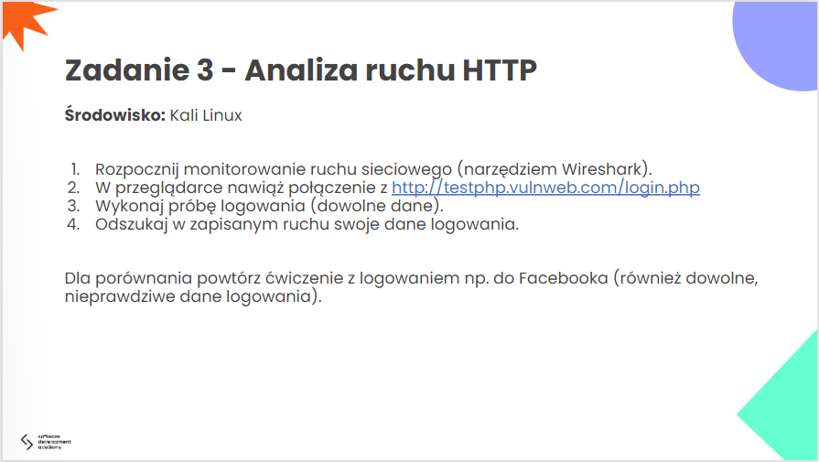

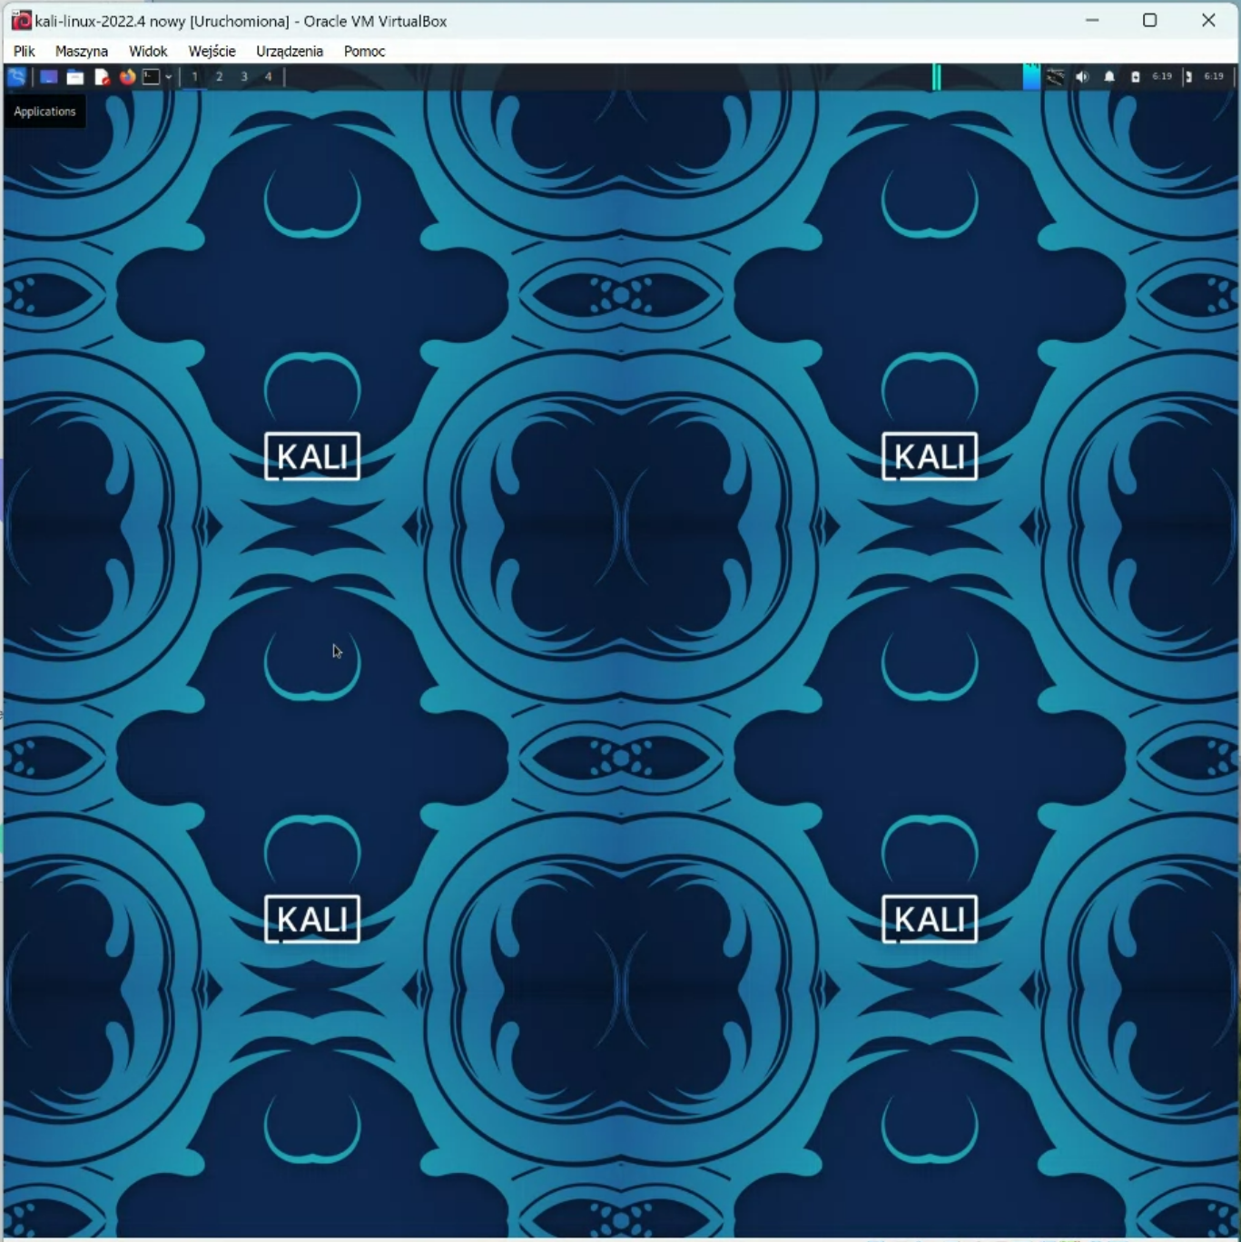

#problemy techniczne

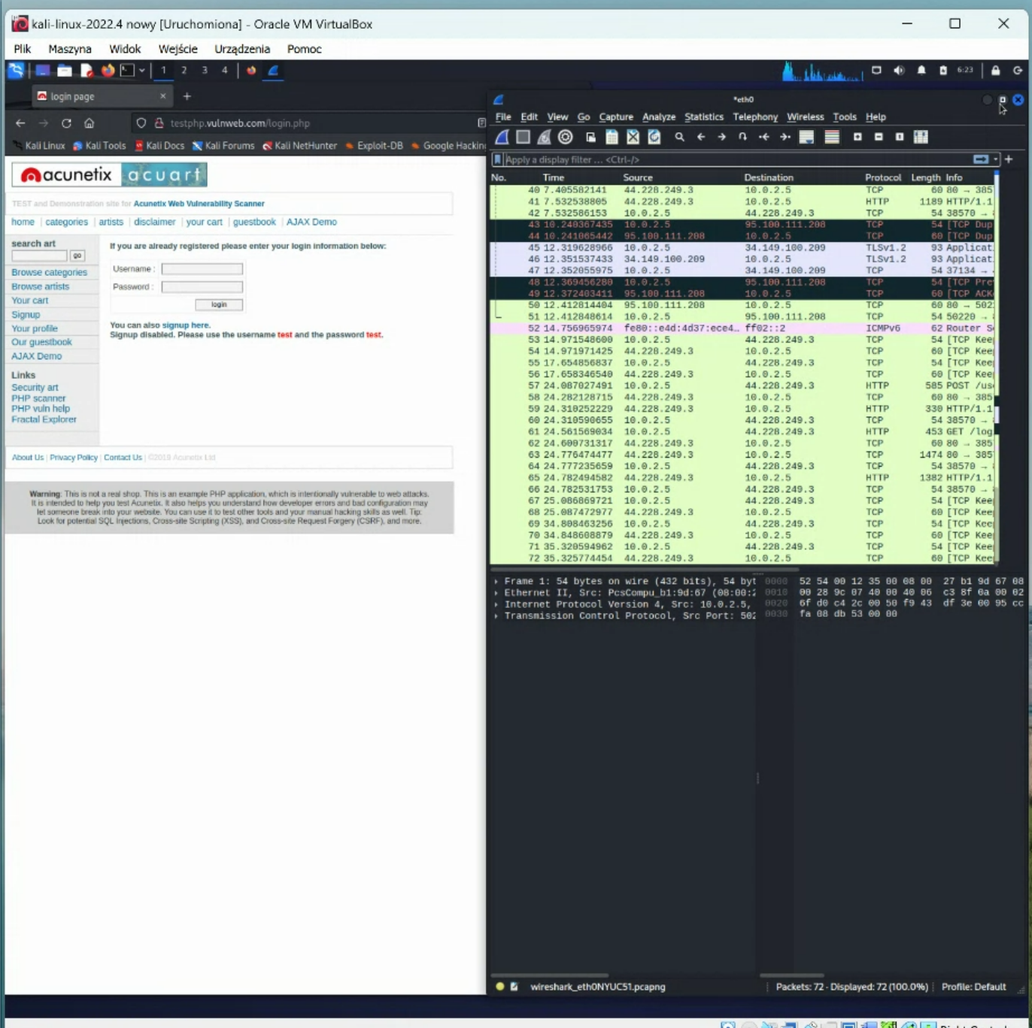

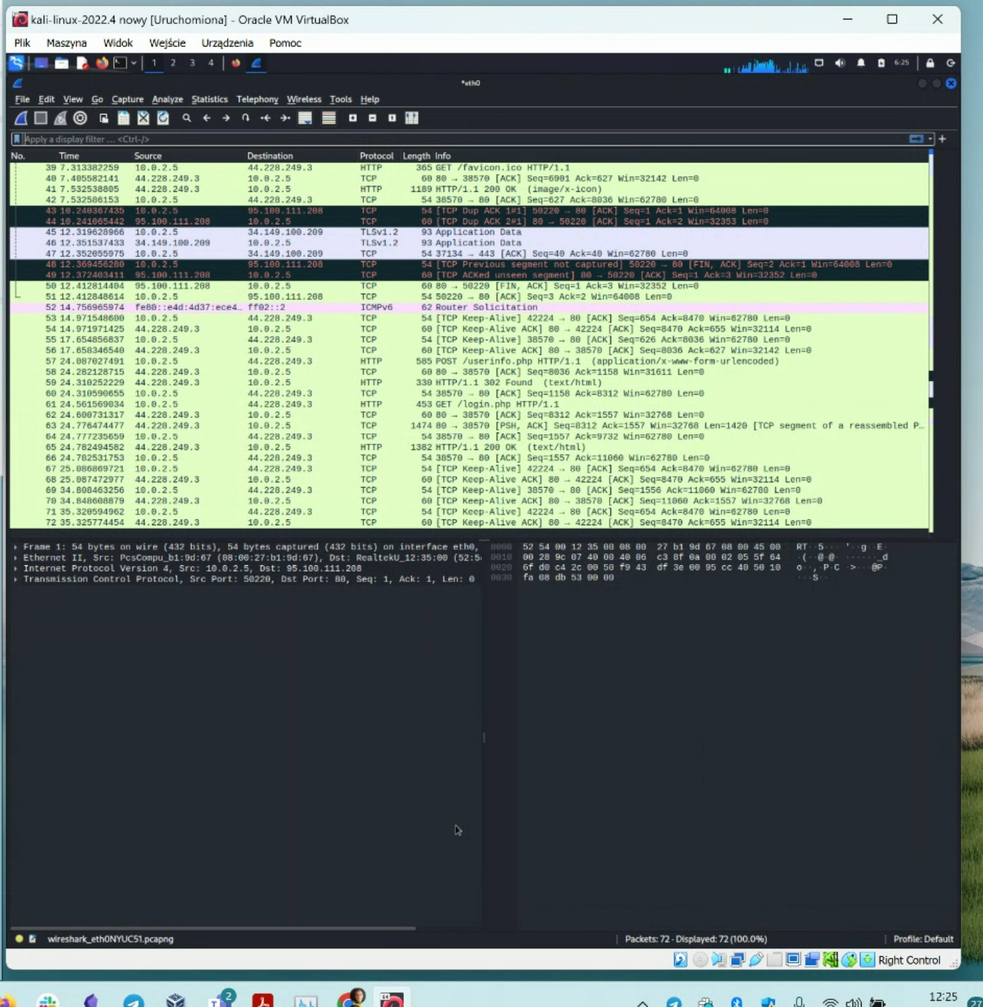

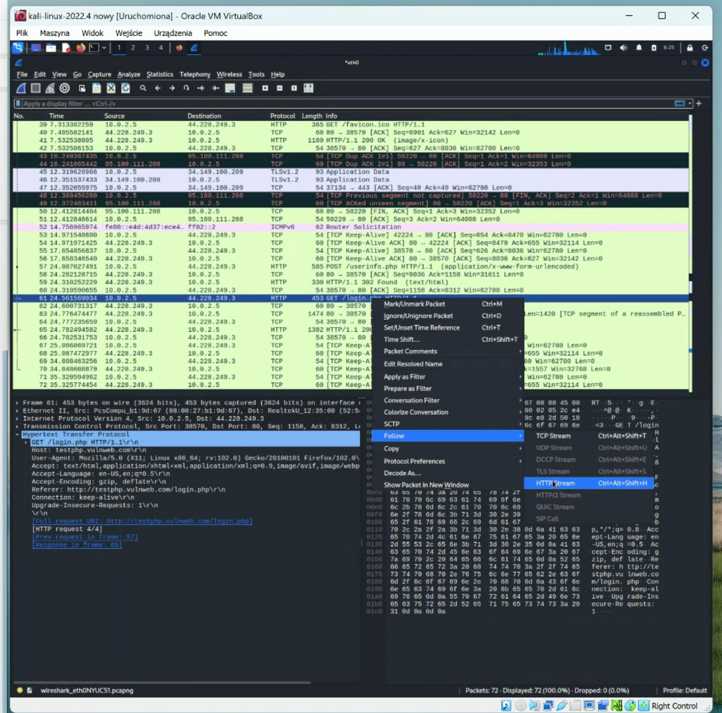

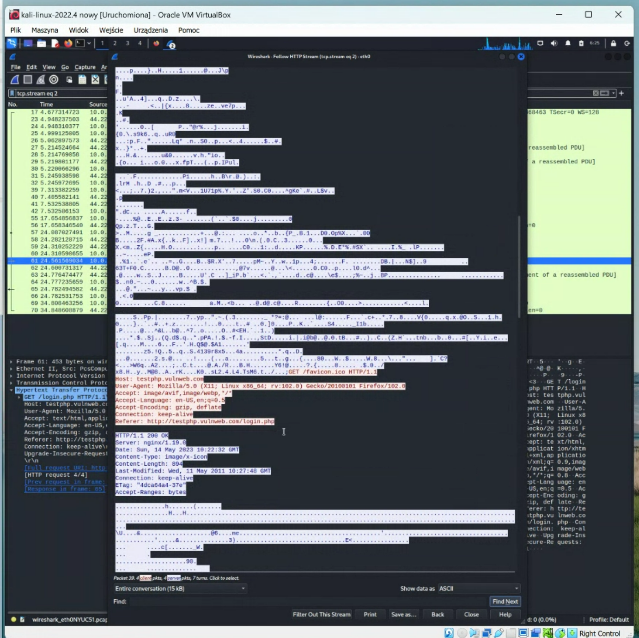

Gdzieś tutaj powinno być to hasło:

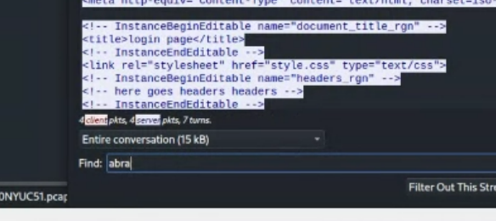

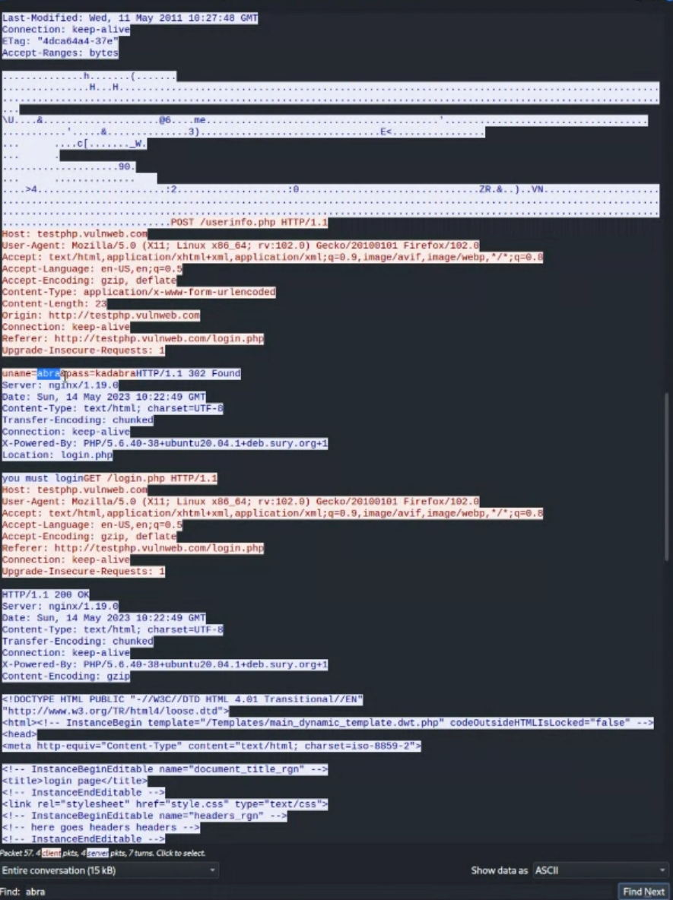

Host: testphp.vulnweb.com

User-Agent: Mozilla/5.0 (X11; Linux x86_64; rv:102.0) Gecko/20100101 Firefox/102.0

Accept: text/html,application/xhtml+xml,application/xml;q=0.9,image/avif,image/webp,*/*;q=0.8

Accept-Language: en-US,en;q=0.5

Accept-Encoding: gzip, deflate

Content-Type: application/x-www-form-urlencoded

Content-Length: 23

Origin: http://testphp.vulnweb.com

Connection: keep-alive

Referer: http://testphp.vulnweb.com/login.php

Upgrade-Insecure-Requests: 1

uname=abra&pass=kadabraHTTP/1.1 302 Found

Server: nginx/1.19.0

Date: Sun, 14 May 2023 10:22:49 GMT

Content-Type: text/html; charset=UTF-8

Transfer-Encoding: chunked

Connection: keep-alive

X-Powered-By: PHP/5.6.40-38+ubuntu20.04.1+deb.sury.org+1

Location: login.php

……………………………………………………………………………………………………………………………………………….

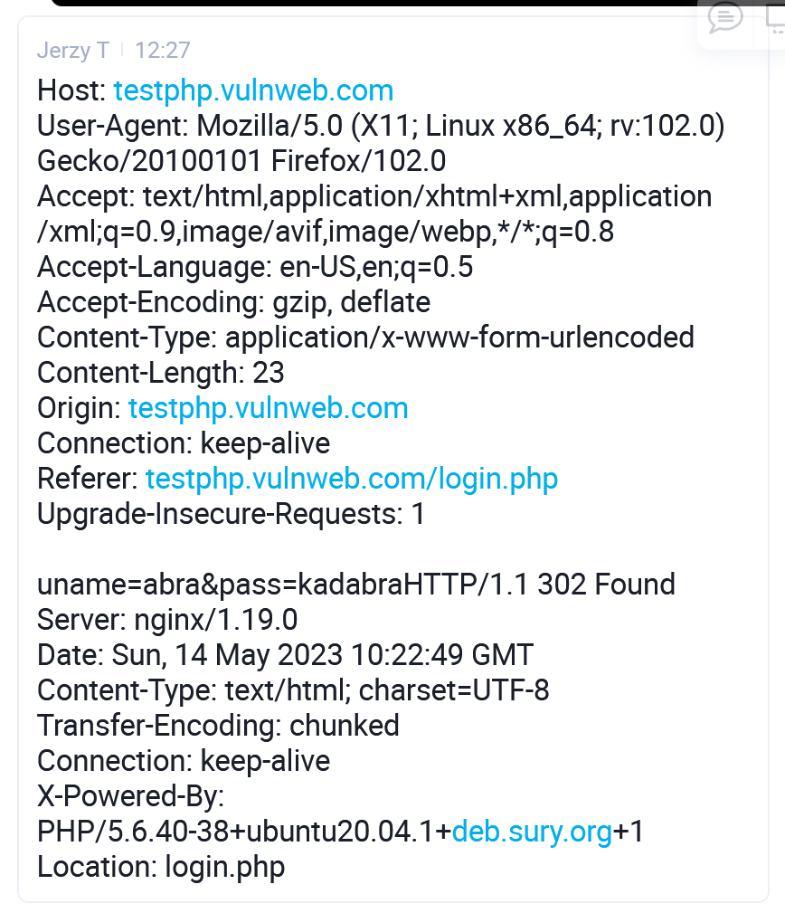

…………………………………………………………………………………………

Teraz szukamy gdzie jest password.

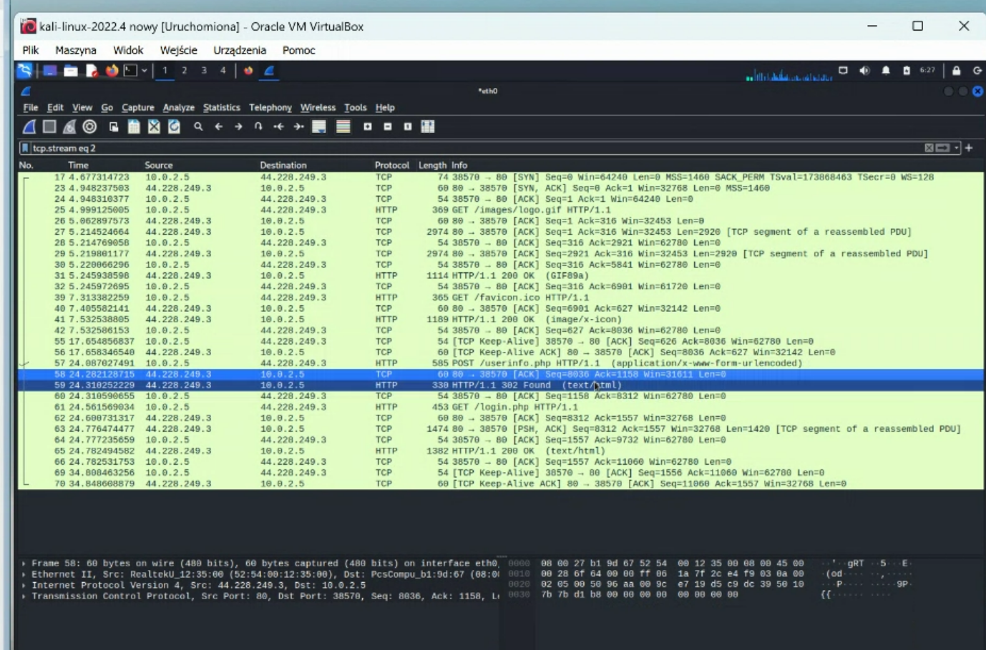

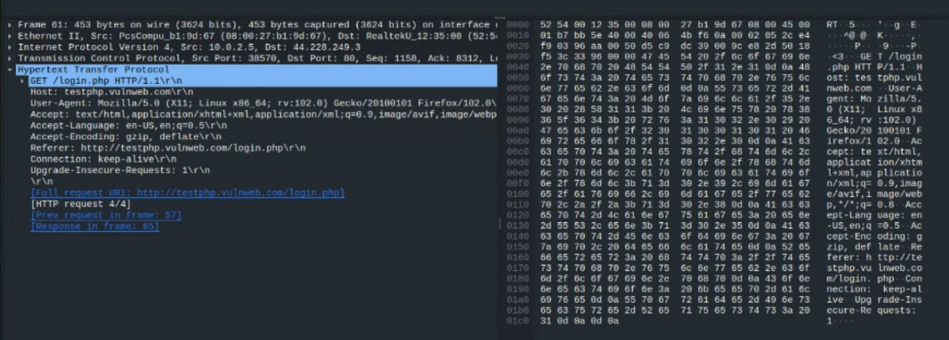

70 nicków było tylko.





Tu jest login

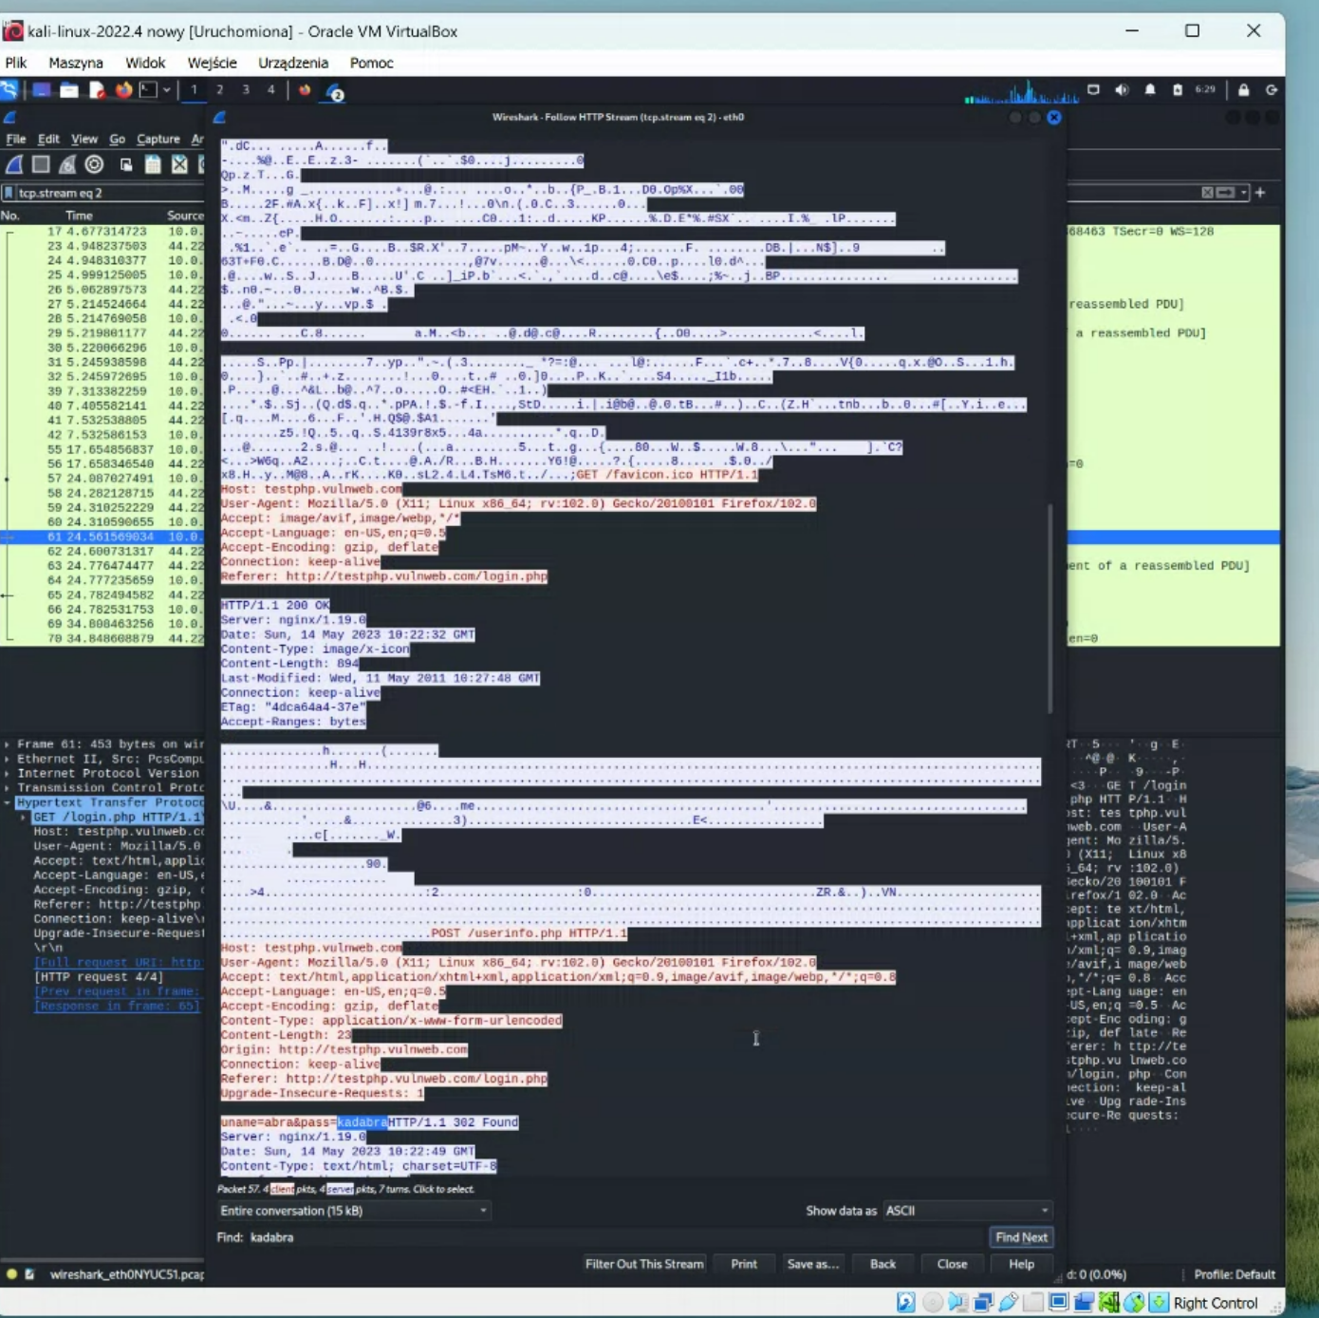

Używamy polecenia w pasku na dole – Find.

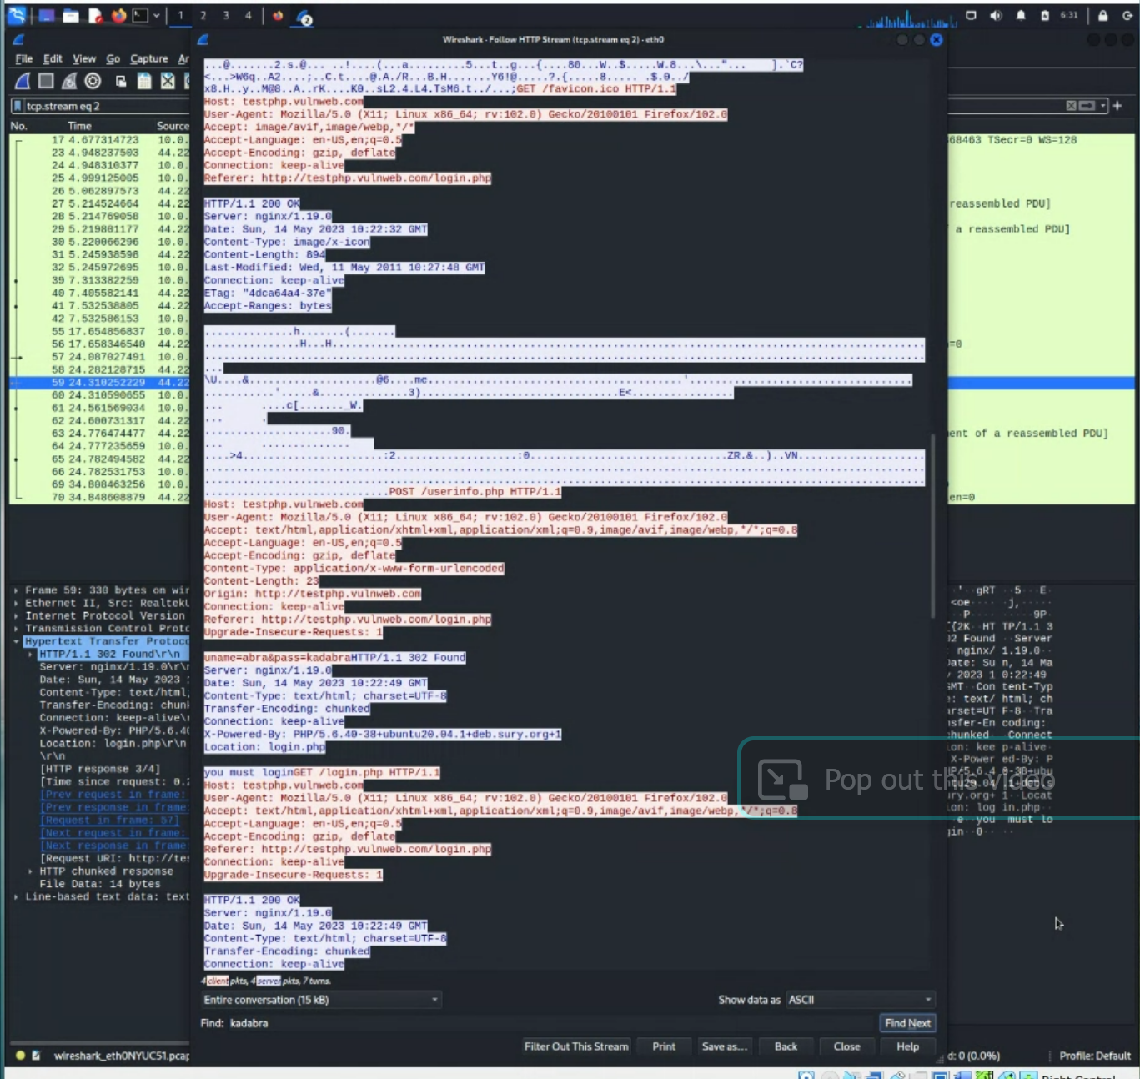

Plus Jerzy skopiował:

…………………………………………….

Host: testphp.vulnweb.com

User-Agent: Mozilla/5.0 (X11; Linux x86_64; rv:102.0) Gecko/20100101 Firefox/102.0

Accept: text/html,application/xhtml+xml,application/xml;q=0.9,image/avif,image/webp,*/*;q=0.8

Accept-Language: en-US,en;q=0.5

Accept-Encoding: gzip, deflate

Content-Type: application/x-www-form-urlencoded

Content-Length: 23

Origin: http://testphp.vulnweb.com

Connection: keep-alive

Referer: http://testphp.vulnweb.com/login.php

Upgrade-Insecure-Requests: 1

uname=abra&pass=kadabraHTTP/1.1 302 Found

Server: nginx/1.19.0

Date: Sun, 14 May 2023 10:22:49 GMT

Content-Type: text/html; charset=UTF-8

Transfer-Encoding: chunked

Connection: keep-alive

X-Powered-By: PHP/5.6.40-38+ubuntu20.04.1+deb.sury.org+1

Location: login.php

…………………………….

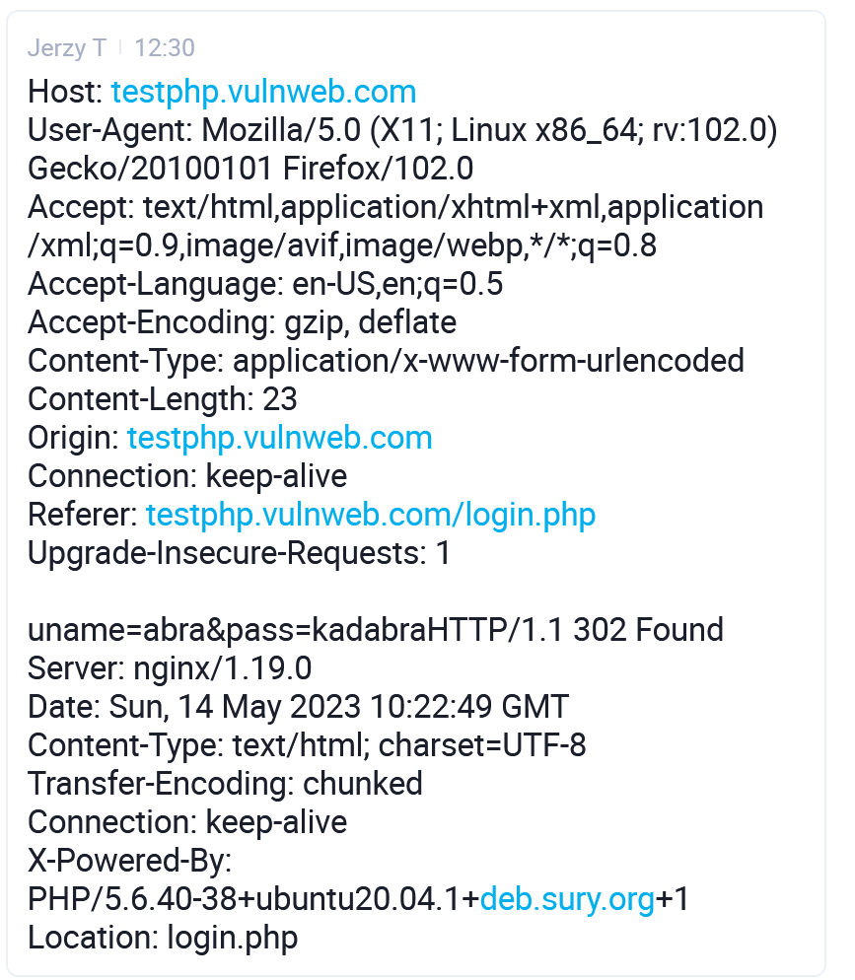

Czyli zrobiliśmy dla punktu 2-ego z zadania 3, a teraz będziemy robili dla Facebook’a.

………………………………………………………………………………………………………………………………………………

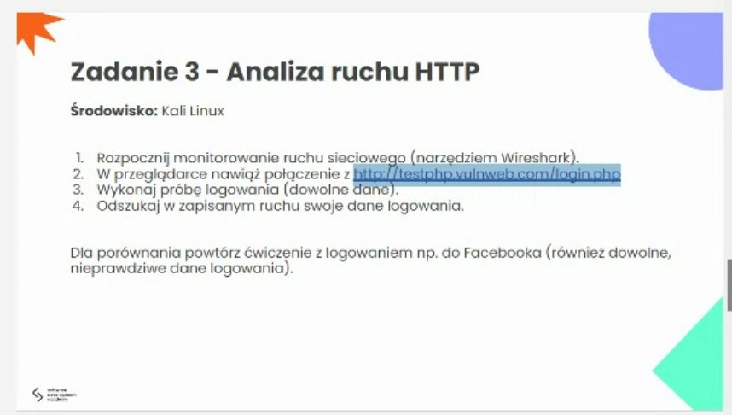

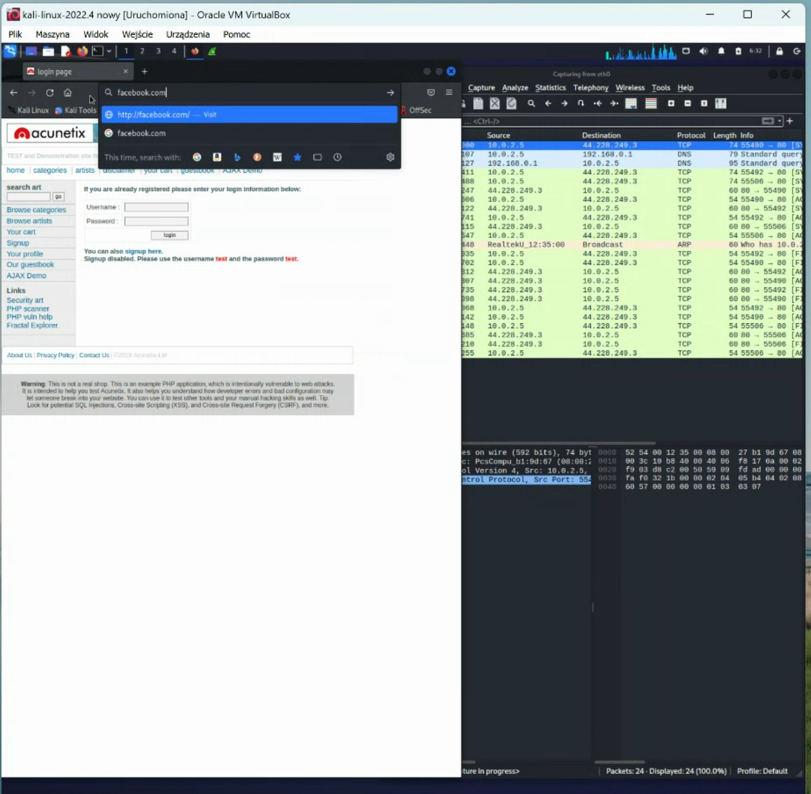

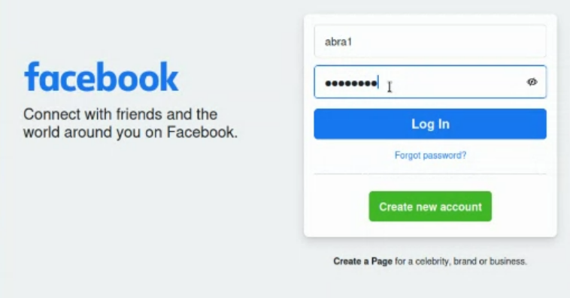

Abra1

Kadabra1

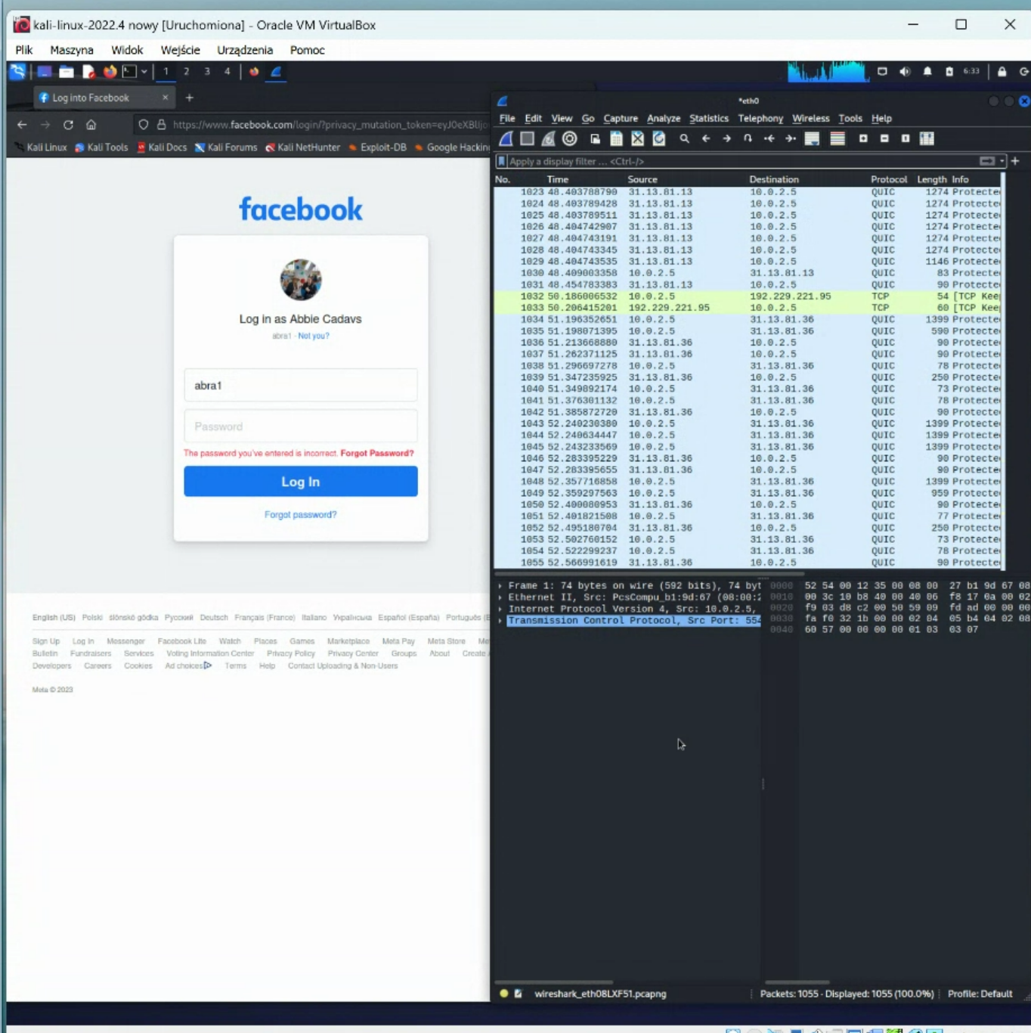

Powiększamy i szukamy http

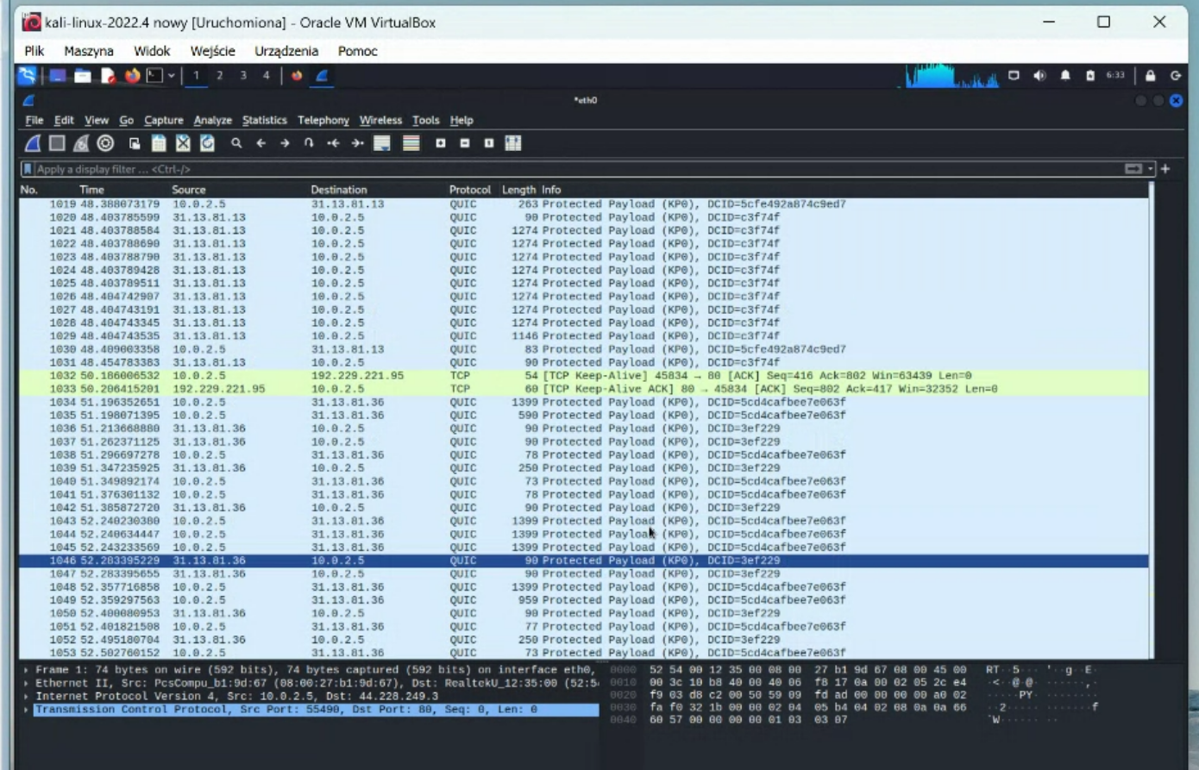

Nadal szukamy http

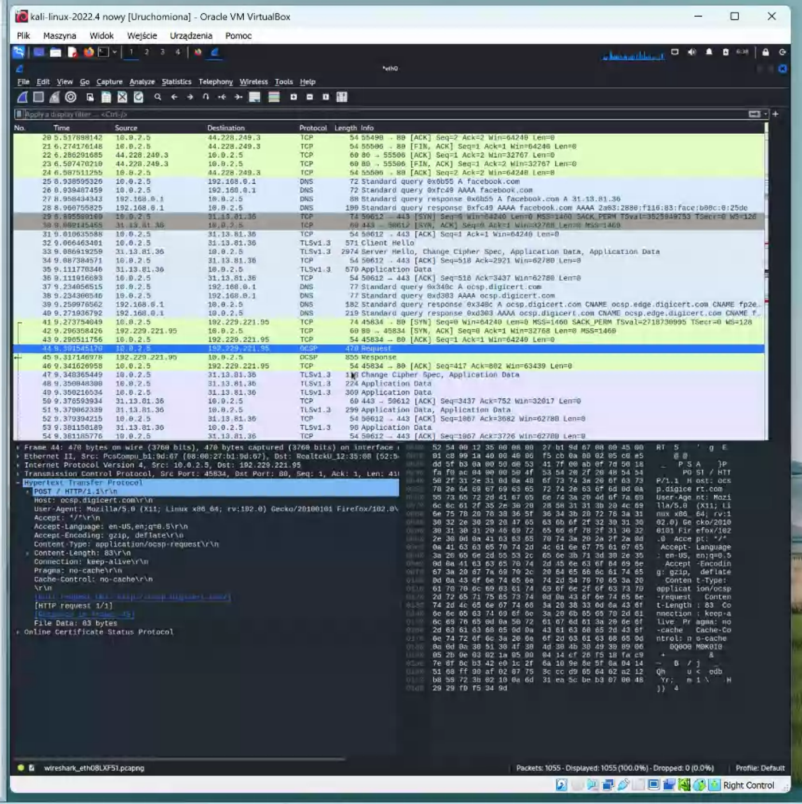

Na razie porzucamy to porównanie. Jakby co to wrócimy do tego później.

……………………………………………………………………………………